FOR IMMEDIATE RELEASE: January 18, 2016

DISTINGUISHED DESIGN TEAM LEADS $150M DENVER ART MUSEUM REVITALIZATION
ArtHouse Design Joins Fentress Architects and Machado Silvetti for Signage Reprise

DENVER, Colo.—11 years after completing work on the Denver Art Museum’s Hamilton Building, ArtHouse Design has also been hired to design the wayfinding and identity signage for the Museum’s North Building revitalization, scheduled to be completed in 2021—just in time for the iconic landmark’s 50th anniversary. The Denver design agency will work directly with local firm Fentress Architects and Boston-based Machado Silvetti to design a coordinated, comprehensive signage program that achieves the Denver Art Museum’s goals for the North project while aligning with the vision of the Museum’s original designer, Gio Ponti.

“As the only environmental graphic design team that has worked on both Denver Art Museum projects, we are honored to be an integral part of the architecture and museum experience by helping to bring together the Hamilton and North Buildings through wayfinding and identity signage,” said ArtHouse Principal Marty Gregg.

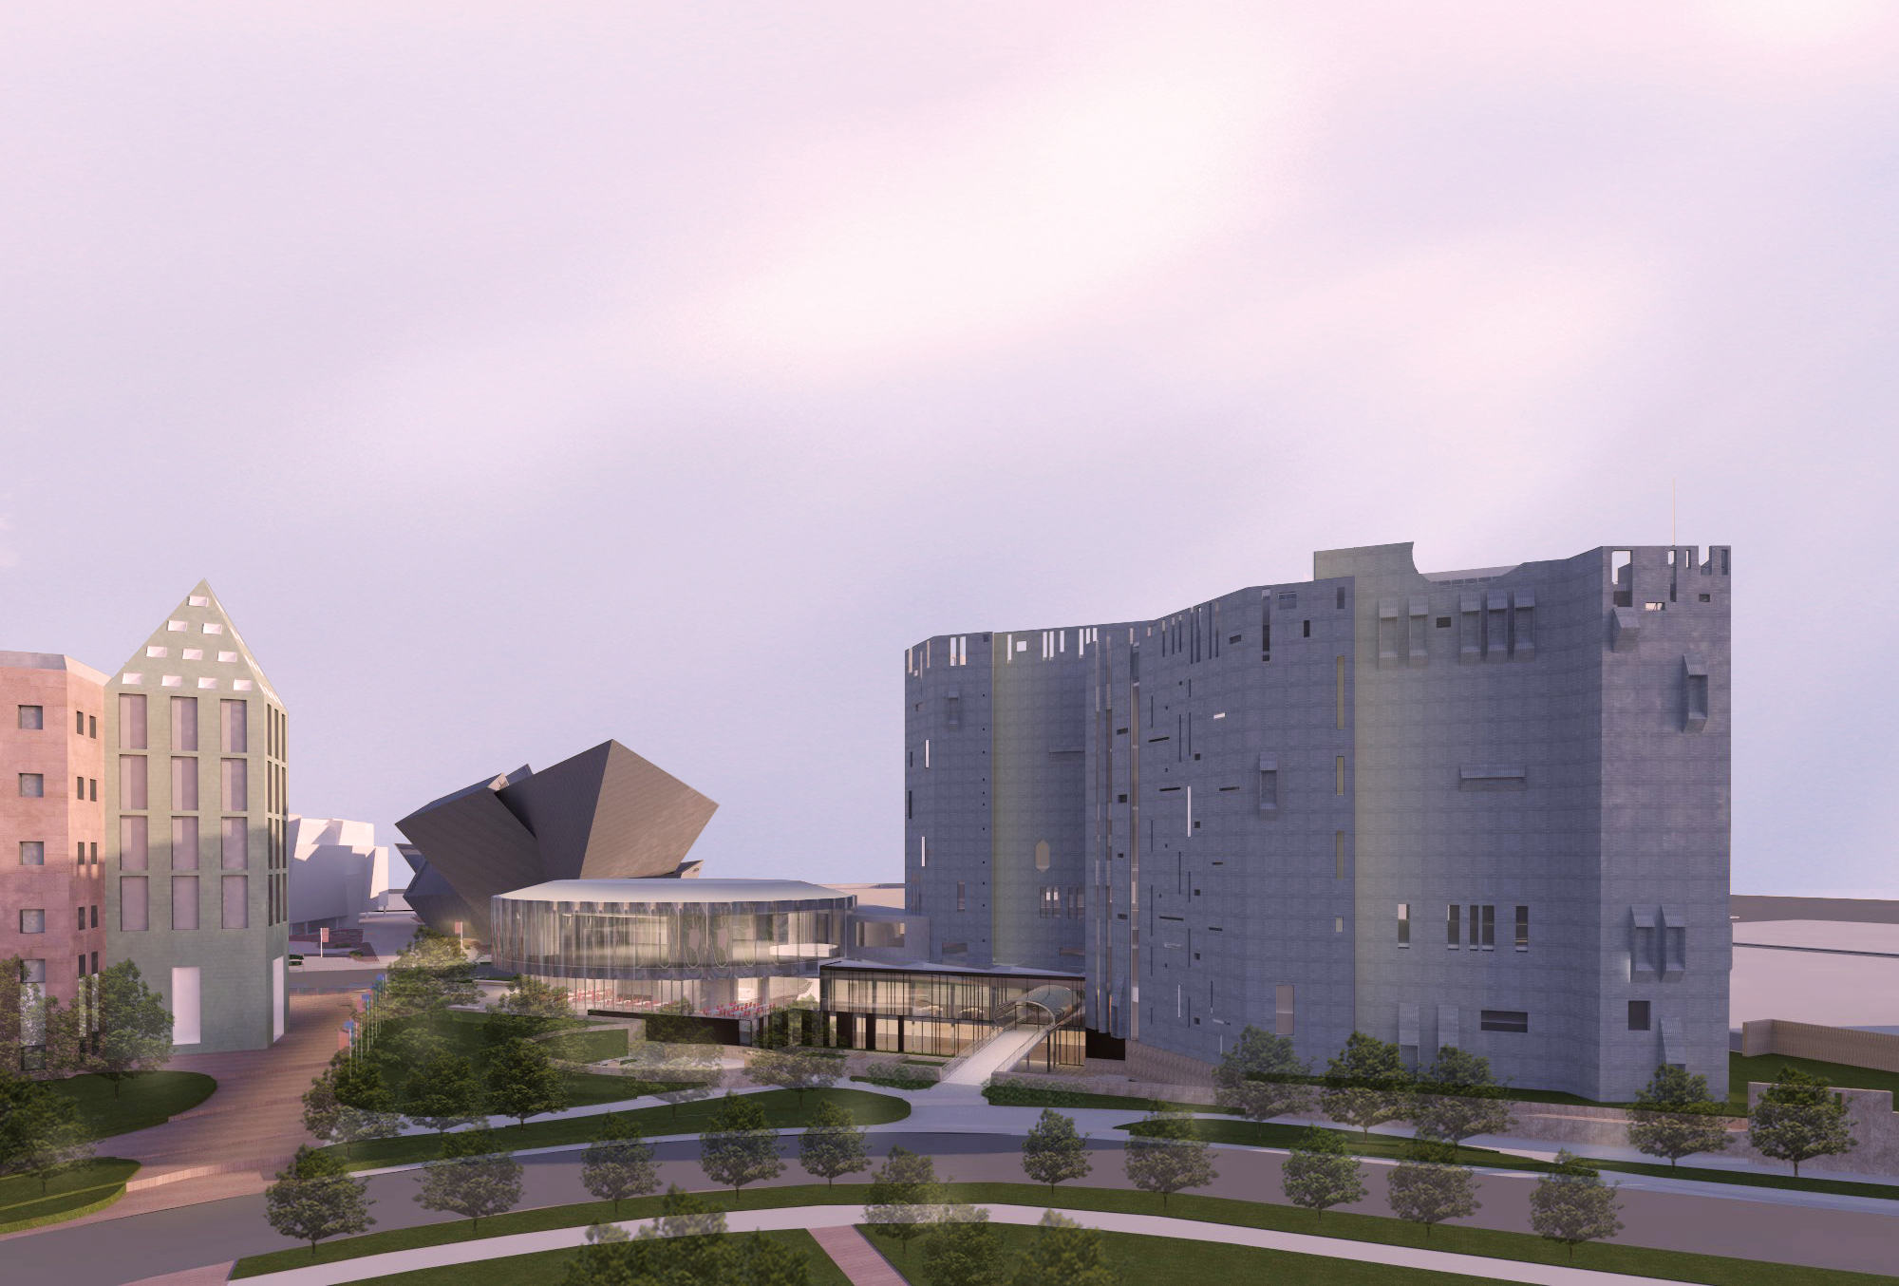
The revitalization of the 7-story modernist structure, highlighted by a new home for the Denver Art Museum’s expansive Western American art collection on the top floor, will unify the Museum campus, improve visitor circulation, expand educational resources and gallery space, add a welcome center and update technology. ArtHouse will focus on building a cohesive, welcoming environment that guides visitors through the entire Museum while blending with the new architecture to support the experience of enjoying art.

“Our primary goal for the North Building’s signage is to complement the architecture both aesthetically and functionally and to do so without distracting visitors,” said ArtHouse Design Director Beth Rosa. “This presents several challenges to overcome, and we’re looking forward to collaborating with Fentress Architects and Machado Silvetti to employ materials, dimensions and shapes in designing innovative yet sensible solutions.”

For example, some of the signs need to be changed easily and quickly to accommodate the Museum’s temporary and traveling exhibitions. And, a variety of competing visual elements need to be connected and integrated without becoming lost.

“The Civic Center Cultural Complex, which encompasses the Denver Art Museum, has so much character that makes it one of Denver’s most interesting areas to walk around,” said ArtHouse Senior Designer Zach Kotel. “With several attractions within a 1-block radius, from the Byers-Evans House and Clyfford Still Museums to the Denver Public Library’s Central Library, it’s important for us to design beautiful, thoughtful signage that’s easy on the eyes—and the feet—to help people get to where they want to be.”

-more-

ArtHouse Design has won numerous industry and civic awards from HOW, GDUSA, UCDA, ASLA, Graphis and the City of Denver for its designs of other wayfinding and identity signage programs.

Source: The Written Effect, 720.989.1912

About ArtHouse Design
ArtHouse Design is a Denver-based, full-service design agency devoted to the creation of beautiful, thoughtful design. Nimble and versatile, ArtHouse has a wide range of expertise, from wayfinding and signage to branding and logos, from print and packaging to digital and web. Specializing in designing and shaping user-friendly, built environments, ArtHouse leads the experiential and environmental graphic design industry in art direction for architecture and interior design. Principal Marty Gregg actively leads in the design community, serving as vice president for development at AIGA Colorado and president of the Community College of Denver's design advisory board. Gregg is also a member of the advisory board to Colorado State University’s design department, serves on the Mayor’s Committee on Vital Signs for the City and County of Denver, and engages in speaking events across the country. At ArtHouse, Gregg leads a team of designers who creatively develop, enhance and reinvigorate brands while communicating their clients’ visions and goals. Maintaining the highest standards for both their work and relationships with clients, ArtHouse designers are constantly endeavoring to share their passion for design and to make it an enjoyable and fulfilling process along the way. For more information, visit www.arthousedenver.com.

Media Contacts
ArtHouse Design: Mindy Viering, Writer, Editor and PR Specialist
(call/text) 720.989.1912, mindy@thewritteneffect.com

Click here to download high-resolution photos.
Click here to visit ArtHouse Design's online newsroom.

###

