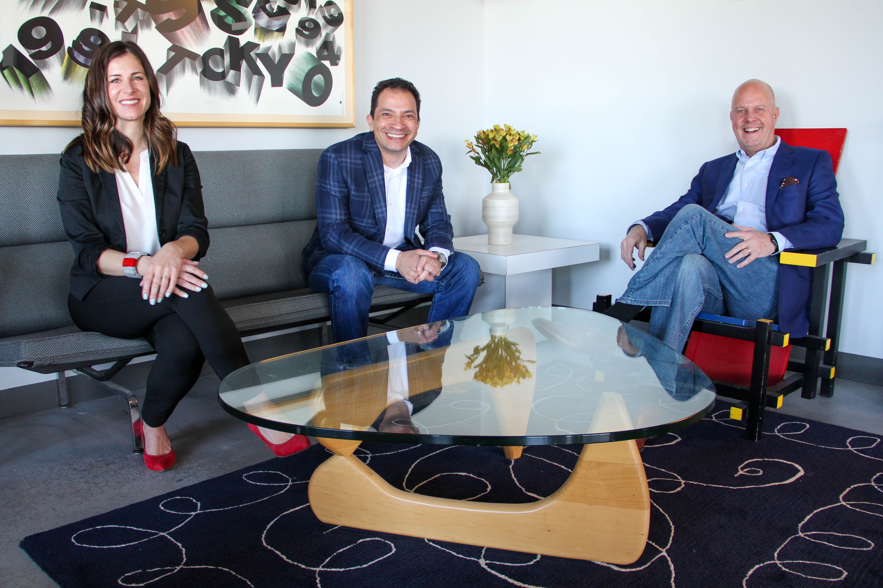
FOR IMMEDIATE RELEASE: February 3, 2021

DENVER DESIGN AGENCY EXPANDS LEADERSHIP TEAM WITH NEW PARTNERS

Bigger, Better, Stronger: ArtHouse Design Optimistic About Continued Growth and Success

DENVER, Colo.—Amidst a slew of design industry mergers and buyouts, ArtHouse Design continues to stand on its own as a leader in branding and experiential graphic design. Today, ArtHouse announces its transition from a sole proprietorship to a three-member partnership that combined has over 70 years of experience, over 100 awards and countless shared memories. Design industry veterans Beth Rosa and Chuck Desmoineaux join founder Marty Gregg as co-principals to lead ArtHouse into the future with its unique philosophy — ask them about the three Ps — and culture. The new leadership team will offer a fresh perspective, working toward goals of elevating the firm and its designers, expanding its reach locally and internationally and continuing to create award-winning, exceptional work. A formal celebration is planned for a later date to be announced when it’s safer to get together.

“Sharing leadership is a natural evolution for ArtHouse, a level up from our achievements over the years: collaborative relationships, proven processes, superior service,” said ArtHouse Co-Principal and Founder Marty Gregg. “With this partnership, we will combine and complement each other’s strengths to bring more experience, more knowledge, more skills and more vision to our creative work, which will in turn allow us to be more strategic with the growth of our business.”

Beth Rosa will continue to manage ArtHouse’s team of award-winning designers, bolster client relationships and grow the firm, together with Desmoineaux. With a remarkable level of dedication and service, Rosa has taken on increasing responsibilities since joining ArtHouse 10 years ago, including design direction for the past five. Her promotion has been several years in the making, as she has more recently been playing a key role in strategic decision-making and business development alongside Gregg. With a perceptive eye and analytic mind, Rosa is particularly accomplished in experiential graphic design and wayfinding signage for healthcare, hospitality, residential and government. Most notably, she has worked on Golisano Children’s Hospital signage/wayfinding, donor and theming, Rochester Regional Health - Sands Constellation Center for Critical Care signage/wayfinding, donor recognition and theming, Colorado State Capitol signage and wayfinding, Umm Al Emarat Park - Abu Dhabi bilingual signage and wayfinding and Parq on Speer signage, theming and wayfinding.

“Our best work is a product of collaboration, when everyone contributes different ideas and perspectives that challenge each other to be better — as individuals and as a team,” said Rosa. “I’m proud to have led ArtHouse’s evolution and growing success and excited about the possibilities for the next 10 years and more. I look forward to guiding and lifting up our talented designers to even bigger and better things to come.”

Chuck Desmoineaux returns to ArtHouse after seven years, though he first met Gregg in 1998 when they connected over his self-made, bomb-proof, aluminum portfolio case. With extensive experience working on teams and projects with ArtHouse and other top, nationally recognized design firms in Colorado, Desmoineaux contributes design expertise in visual communication, wayfinding, brand identity and built environments, especially for retail, entertainment and hospitality. While previously at ArtHouse, Desmoineaux, along with Rosa, was a senior designer, art directing and leading a variety of branding and experiential graphic design projects. Most notably, he worked on Denver Art Museum - Hamilton Building wayfinding and donor recognition, Golisano Children’s Hospital theming, wayfinding and donor signage and Museum of Outdoor Arts brand identity and signage.

“Amazing things happen on the edges of different design disciplines and where they intersect — and that’s where we get to work,” said Desmoineaux. “For me, this is an opportunity to align with a leader in the industry while strengthening our relationships and helping design our business as we look to the future. I’m excited and honored to be back with ArtHouse in this new leadership role, mentoring, designing and working alongside a very talented studio of designers — these are people I admire, trust and believe in.”

Marty Gregg will continue to lead ArtHouse in solving design challenges through his passion for art, love of teaching and flair for storytelling. Since founding the firm nearly 30 years ago, Gregg has cultivated design talent by offering autonomy and room to think outside — and obliterate — the proverbial box, with often surprising and always extraordinary results.

“ArtHouse remains steadfast in our commitment to creative partnerships while producing imaginative, high-quality work,” said Gregg. “Together with our wonderful clients, we will continue to dream big and stand on our toes to reach an even higher level of excellence.”

ArtHouse has won numerous distinctions for the team’s design talents from Graphis, GDUSA American Graphic Design Awards, HOW International Design Awards, Transform Awards - North America, University and College Designers Association, Corporate Content Awards, Colorado Business Committee for the Arts, Downtown Denver Partnership, The One Club for Creativity, NAIOP Colorado and the City of Denver Mayor’s Design Awards.

To learn more and work with the ArtHouse Design team, visit https://arthousedenver.com/.

About ArtHouse Design
ArtHouse Design is a Denver-based, full-service design firm devoted to the creation of beautiful, thoughtful design. Nimble and versatile, ArtHouse has a wide range of expertise, from wayfinding and signage to branding and identity, from print and packaging to donor recognition. Specialists in designing for and shaping user-friendly, built environments, ArtHouse leads the experiential graphic design community in design implementation for placemaking, partnering with architects, municipalities, developers and interior designers to improve public spaces. For more, visit ArtHouse’s blog and follow their social media channels on Facebook, Twitter and Instagram.

Media Contact

Mindy Viering, Chief Content Officer, The Written Effect, (call/text) 720.989.1912, mindy@thewritteneffect.com

Download high-resolution photos.
Visit ArtHouse Design's online newsroom.

