FOR IMMEDIATE RELEASE: Monday, Mar. 14

DENVER DESIGN AGENCY MAKES KIDS' HOSPITAL VISITS LESS SCARY, MORE FUN
ArtHouse Design Completes Signage Program for New, $145M Golisano Children's Hospital

DENVER, Colo. and ROCHESTER, NY—Denver design agency ArtHouse Design recently completed a major theming, wayfinding and donor signage program for Phase I of the new Golisano Children's Hospital (GCH) at Strong Memorial Hospital in Rochester, New York. Part of the University of Rochester Medical Center, the $145-million, 245,000-square-foot facility features eight stories, 52 private rooms and 68 neonatal intensive care unit (NICU) beds to offer more space for families and life-saving medical equipment, as well as increased privacy. GCH was dedicated with a ribbon-cutting ceremony May 27, 2015, and opened its doors to patients on July 7 that same year.

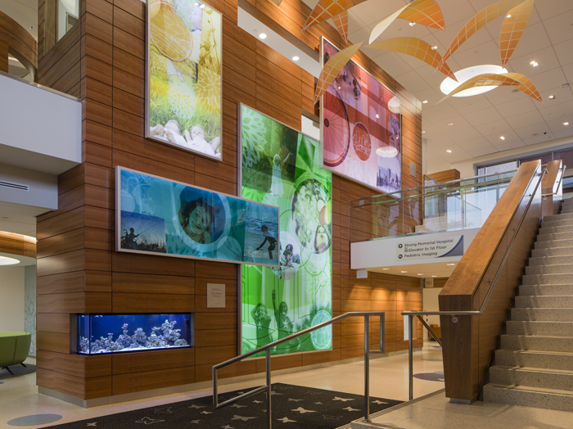
"Hospital visits can be scary for kids, who are being poked and prodded and hooked up to noisy machines," said ArtHouse Design Senior and Project Lead Designer Beth Rosa. "To reduce stress and anxiety during their stay, we created a warm, inviting and comfortable environment through playful distractions mixed with quiet areas. It gives me great pleasure to see the ease and enjoyment thoughtful design brings to children and their families."

The distinct surroundings of Upstate New York inspired ArtHouse's overall design concept, with six of the eight levels featuring a different landscape: lake, meadow, glen, garden, park and city. Deliberately intended for hands-on fun, the design elements feature round, child-friendly objects; safe, durable materials; and age-appropriate, engaging activities—while functioning to help visitors navigate the different levels and areas of the hospital.

"Golisano Children's Hospital makes a huge impact on the Finger Lakes region and across the country, so we really wanted to distinguish it from other children's hospitals," said Rosa. "From the carpets to the walls and the spaces in between, we've incorporated multi-layered color gradations, vibrant photos and images, and interesting textures for kids to experience something new each and every visit."

Highlights of ArtHouse's custom theming, wayfinding and donor signage program include:
- a larger-than-life-sized, Lite Brite-style activity wall in the 8th-floor waiting room
- dioramas with mini, hand-painted trains in the 7th- and 8th-floor corridors
- wall-embedded turn-and-crank automatas (mechanical toys) and kinetic games
- a life-size, 15-piece puzzle in the 7th-floor waiting room
- a word-search game fabricated with etched and painted wood outside the 7th-floor waiting room
- sound modules on occupiable walls of the ground and first floors—frogs ribbit, bubbles pop, cars honk and more to fit with each floor's theme
- back-lit, floor-to-ceiling impact graphics and photographic murals on each floor
- a nursery-themed NICU
- illuminated nurses' station desks, with seamless panels of corian (elegant, white stone) and etched butterfly patterns, that create a soft, warm glow
- 5-foot-diameter, back-lit graphic icons that identify the themed level in elevator lobbies

-more-
- glass interlayer graphics that sit between two 1/4” pieces of glass for the NICU patient room sliding doors, with different color palettes for each "neighborhood"
- uniquely designed, butterfly-patterned walk-off mats for the building entrances to catch mud, dirt and snow from foot traffic
- Playdeck floor graphics made out of gym-floor material and featuring fish ponds with lilypads and stepping stones

ArtHouse teamed up with Ballinger, an architecture and engineering firm based out of Philadelphia, Pennsylvania, to complete this 3-year Phase I project on time and on budget. ArtHouse is currently working with HDR Architects based out of New York City on the theming, wayfinding and donor signage program for Phase II—floors four and six—of the new GCH, scheduled to be open for patient occupancy in May 2017. Phase II features operating and recovery rooms, a gastroenterology surgical procedure suite and a dedicated pediatric catherization/electrophysiology laboratory on the fourth floor, as well as a pediatric intensive care unit (PICU) on the sixth.

"It's well-documented that artful environments help the healing process," said ArtHouse Principal and Creative Director Marty Gregg. "The ArtHouse Design team is thrilled to use our skills in designing the built environment for children's hospitals, because, at the end of the day, our work makes people feel better."

Source: The Written Effect, 720.989.1912

About ArtHouse Design
ArtHouse Design is a Denver-based, full-service design agency devoted to the creation of beautiful, thoughtful design. Nimble and versatile, ArtHouse has a wide range of expertise, from wayfinding and signage to branding and logos, from print and packaging to digital and web. Specializing in designing and shaping user-friendly, built environments, ArtHouse leads the experiential and environmental graphic design industry in art direction for placemaking, such as architecture and interior design. Principal and Creative Director Marty Gregg actively leads in the design community, serving as vice president for development at AIGA Colorado and president of the Community College of Denver's design advisory board. Gregg is also a member of the advisory board to Colorado State University’s design department, serves on the Mayor’s Committee on Vital Signs for the City and County of Denver, and engages in speaking events across the country. At ArtHouse, Gregg leads a team of designers who creatively develop, enhance and reinvigorate brands while communicating their clients’ visions and goals. Maintaining the highest standards for both their work and relationships with clients, ArtHouse designers are constantly endeavoring to share their passion for design and to make it an enjoyable and fulfilling process along the way. For more information, visit www.arthousedenver.com.

About Golisano Children's Hospital at Strong Memorial Hospital
Golisano Children’s Hospital employs more than 200 pediatric specialists and provides a spectrum of care that spans more than 40 specialty areas, serving the more than 85,000 children and their families each year. It serves as the referral center for all seriously ill or injured children from the 17-county Finger Lakes region and beyond. Our missions are to provide comprehensive care for children and their families, educate future pediatricians and pediatric specialists, and perform progressive research that will lead to the medical breakthroughs of tomorrow. For more information, visit www.urmc.rochester.edu/childrens-hospital.

-more-

Media Contacts
ArtHouse Design: Mindy Viering, Writer, Editor and PR Specialist
(call/text) 720.989.1912, mindy@thewritteneffect.com

Golisano Children's Hospital: Rebecca Youmell, Communications Coordinator
585.276.4298, rebecca_youmell@urmc.rochester.edu

Click here to download high-resolution photos from ArtHouse Design's online newsroom.

###

