FOR IMMEDIATE RELEASE: August 1, 2017

MEET THE DENVER DESIGN AGENCY BEHIND MAIN CITY STREET’S BOLD, NEW LOOK
Join ArtHouse Design at community event to celebrate Colfax Avenue

DENVER, Colo.—Colfax Avenue is looking brighter, and people are taking notice. Find out what all the buzz is about at Art-i-Fax, a local street party and art fair at the intersection of Colfax and Park Avenues, on Saturday, Aug. 12, 2017, from 10 a.m. to 4 p.m. ArtHouse Design, the Denver design agency responsible for Colfax’s brand identity package, including logos, icons, a responsive website and street banners, invites Denver residents and visitors to come for the free koozies—and stay for the live music, local art, street food and cold beer.

ArtHouse’s municipal branding for Colfax, a bustling street often associated with a colorful past, is part of a greater effort led by the Colfax Ave Business Improvement District (Colfax Ave BID) to enhance safety guides, respect the historic nature of the street and improve the pedestrian experience, while keeping Denver’s independent and original street thriving. Through the brand, residents, visitors and businesses can show their pride in the diverse neighborhood.

“We’re respectfully toeing the line between legacy and progress to redefine development in Denver,” said ArtHouse Senior Designer Zach Kotel. “Rather than ‘out with the old, in with the new’, our community-oriented designs are helping to revitalize a historic area that is known for being unapologetically gritty to maintain a more local, authentic feel compared to other changing Denver neighborhoods.”

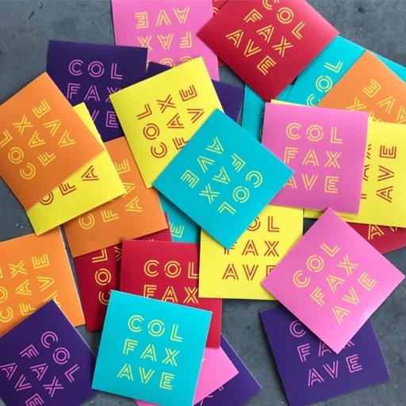
Inspired by Colfax’s unique view from east to west—Playboy dubbed Colfax “the longest, wickedest street in America”—the vibrant color scheme represents the spectrum of hues that can be seen while walking down the street at sunrise and sunset. And the typography evokes images of iconic neon signs that continue to line the eclectic thoroughfare.

“We build a lot of brands that have to be grown up, but this identity is spunky and spirited, just like Colfax,” said ArtHouse Principal and Creative Director Marty Gregg. “It subscribes to all the rules of a successful brand, but we’ve kept the uncompromised verve it had during its first inception and people are noticeably connecting with it.”

Colfax Ave BID hit a snag in June when its funding from Denver City Council’s 2017 General Obligation (GO) Bond was drastically reduced. But the community showed its love for Colfax by appealing to the Denver City Council, and Mayor Hancock announced reinstatement of the funds in July, pending City Council review, as well as a public vote in November.

To show their support, ArtHouse is the leading sponsor for Art-i-Fax, donating design and event marketing services to Colfax Ave BID. “Our in-kind donation is an investment in a community we love,” said Gregg. “We’ve had two offices along the corridor, one of which was across the street from a firehouse. Client meetings used to get interrupted by sirens that made us feel like trucks were tearing through the room.”

-more-
Colfax has a nostalgic effect like this on just about everyone who has lived in or visited Denver, conjuring up stories of fun, excitement and sometimes trouble. With this in mind, ArtHouse also designed a branded collection of swag, including stickers, t-shirts, posters and tote bags, that people can buy. With a variety of logos and colors to choose from, they can unite with Colfax yet express themselves individually.

“With guerrilla marketing, we’re hoping to attract more intrigue, development and investment along the corridor,” said Kotel. “The main idea is that all are welcome on Colfax, from its old, seedy lounges to its hip, crowded patios, and together, we can make the community an even better place to live, work and play for decades to come.”

ArtHouse has won numerous industry and civic awards from Graphis, ASLA, HOW, GDUSA and the City of Denver for its work on other municipal brand identity packages, such as Denver’s 14th Street and Mother of the Nation Park in Abu Dhabi, Dubai.

Source: The Written Effect, 720.989.1912

About ArtHouse Design
ArtHouse Design is a Denver-based, full-service design agency devoted to the creation of beautiful, thoughtful design. Nimble and versatile, ArtHouse has a wide range of expertise, from wayfinding and signage to branding and logos, from print and packaging to digital and web. Specializing in designing and shaping user-friendly, built environments, ArtHouse leads the experiential and environmental graphic design industry in art direction for architecture and interior design. Principal and Creative Director Marty Gregg actively leads in the design community, serving as vice president for development at AIGA Colorado and president of the Community College of Denver's design advisory board. Gregg is also a member of the advisory board to Colorado State University’s design department, serves on the Mayor’s Committee on Vital Signs for the City and County of Denver, and engages in speaking events across the country. At ArtHouse, Gregg leads a team of designers who creatively develop, enhance and reinvigorate brands while communicating their clients’ visions and goals. Maintaining the highest standards for both their work and relationships with clients, ArtHouse designers are constantly endeavoring to share their passion for design and to make it an enjoyable and fulfilling process along the way. For more, visit ArtHouse’s online newsroom and blog and follow them on Facebook, Twitter, Instagram and Pinterest.

About Colfax Ave Business Improvement District
The Colfax Ave Business Improvement District (BID), which encompasses Colfax Avenue from Grant to Columbine and 14th to 16th Streets in the Capitol Hill/Uptown neighborhoods of Denver, Colo., exists to promote economic vitality and advocate on behalf of area businesses. A self-taxing, quasi-government entity formed in 1989, BID has overseen improved street maintenance and installation of HALO cameras and historic streetlights, as well as created local events such as the Victorian Holiday House Tour and Root 40 Music Fest. For more, visit BID’s online newsroom and follow them on Instagram, Twitter, Facebook.

Media Contact
Mindy Viering, Writer, Editor and PR Specialist
(call/text) 720.989.1912, mindy@thewritteneffect.com

To download high-resolution photos, visit ArtHouse Design's online newsroom.

###

