FOR IMMEDIATE RELEASE: February 1, 2016

DENVER DESIGN AGENCY'S IN-KIND GIFT ACCENTS $16.1M MUSEUM EXPANSION
ArtHouse Charms Children's Museum Guests with Etch a Sketch-Inspired Motif

DENVER, Colo.—Denver design agency ArtHouse Design celebrated completion of their latest environmental graphic design project—a wayfinding and signage program for the Children's Museum of Denver at Marsico Campus—on Nov. 16, 2015, four days ahead of the newly expanded Museum's grand opening. With a $16.1-million expansion, the local cultural icon and attraction now sits on a 9-acre campus, with double the exhibit space and six new exhibits: Altitude, The Art Studio, Energy, Joy Park, The Teaching Kitchen and Water.

"We were excited to have the opportunity to work with such a positive fixture in the Denver community, but we knew the Museum had limited resources," said ArtHouse Design Principal and Creative Director Marty Gregg. "Because of our support and reputation in Denver and the design industry, we were able to closely coordinate with a talented project team and make an in-kind donation of our design services—and we were thrilled to do it."

ArtHouse worked with local fabricator Ad Light + Sign, who also made an in-kind donation to the Museum, to complete the project under tight budget and time constraints.

"We needed a design agency that would help rally our needs together and propose a simple, clear and beautiful plan to get all our messages across," said the Museum's Associate Director of Marketing and Membership Zoe Ocampo. "Working with a Denver agency that not only had amazing design skills, but also knew signage best practices, codes and rules, as well as the best fabrication vendors in town, was invaluable."

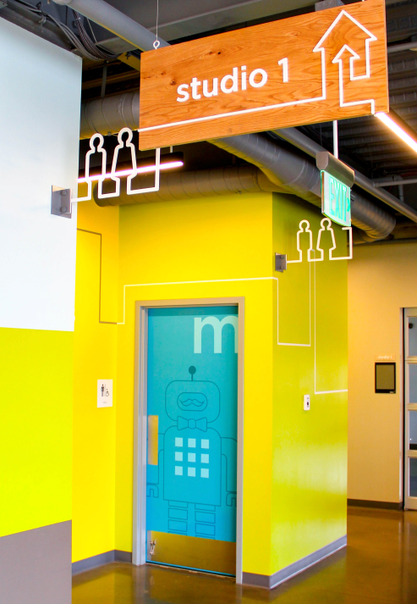
The result was a simple, fun and recognizable wayfinding and signage motif for all ages: Etch A Sketch-inspired lines and shapes combining play, imagination and intellect to lead and direct guests through the Museum.

"Our goal was to distinguish the Children's Museum of Denver at Marsico Campus from the cliché to engage both children and adults, and we were given a lot of flexibility to be creative and inventive," said ArtHouse Project Lead Designer Zach Kotel. "The challenge was to tie together the Museum's new brand, new additions and expanded goals with beautiful, functional signage in a way that was honest, natural and comfortable."

Highlights of the custom wayfinding and signage program:
- a 5'7" x 5'0" multi-color, metal, origami bird installed on the building's exterior above the north-facing entrance
- 12 restroom graphics with male and female robots direct-printed on vinyl and clear-coated for protection
- a supergraphic at the east entrance recognizing the Sturm Family Foundation's donation to fund the dedicated school group entrance
- 10 wayfinding wall graphics to help visitors get around
- Five decorative and functional parking lot banners, as well as a changeable parking entry sign and two pole-mounted parking regulation signs for Museum and other events

-more-

"I've always wanted to design a children's museum, so the opportunity to co-lead this project was incredible," said ArtHouse Project Lead Designer Evan Bethel. "I'm in this industry to help create a positive environment for our community. Through projects like this, we're building relationships while subtly designing Denver."

Source: The Written Effect, 720.989.1912

About ArtHouse Design
ArtHouse Design is a Denver-based, full-service design agency devoted to the creation of beautiful, thoughtful design. Nimble and versatile, ArtHouse has a wide range of expertise, from wayfinding and signage to branding and logos, from print and packaging to digital and web. Specializing in designing and shaping user-friendly, built environments, ArtHouse leads the experiential and environmental graphic design industry in art direction for architecture and interior design. Principal and Creative Director Marty Gregg actively leads in the design community, serving as vice president for development at AIGA Colorado and president of the Community College of Denver's design advisory board. Gregg is also a member of the advisory board to Colorado State University’s design department, serves on the Mayor’s Committee on Vital Signs for the City and County of Denver, and engages in speaking events across the country. At ArtHouse, Gregg leads a team of designers who creatively develop, enhance and reinvigorate brands while communicating their clients’ visions and goals. Maintaining the highest standards for both their work and relationships with clients, ArtHouse designers are constantly endeavoring to share their passion for design and to make it an enjoyable and fulfilling process along the way. For more information, visit www.arthousedenver.com.

About Children's Museum of Denver at Marsico Campus
The Children’s Museum of Denver at Marsico Campus is a 501(c)(3), private, nonprofit organization and a Tier II SCFD member. Since 1973, the Children’s Museum of Denver at Marsico Campus has served the metro-Denver community as a learning institute dedicated to the education and growth of young children and their caregivers. With a mission to create extraordinary experiences that champion the wonder and joy of childhood, the Museum provides rich play experiences and a dynamic learning environment for children to learn through innovative and interactive hands-on exhibits, engaging daily programming and year-round special events. Last year, they served more than 359,000 children and their grownups. For more information, visit mychildsmuseum.org.

Media Contacts
ArtHouse Design: Mindy Viering, Writer, Editor and PR Specialist
(call/text) 720.989.1912, mindy@thewritteneffect.com

Children's Museum of Denver at Marsico Campus: Zoe Ocampo, Associate Director of Marketing and Membership
(o) 303.561.0111, (c) 303.895.0066, zoeo@cmdenver.org

Click here to download high-resolution photos and the project fact sheet from ArtHouse Design's online newsroom.

###

