FOR IMMEDIATE RELEASE: November 15, 2016

DENVER DESIGN AGENCY HELPS ABU DHABI PUBLIC PARK HONOR ITS COUNTRY
ArtHouse reflects on 7-year experiential graphic design project for Mother of the Nation Park

DENVER, Colo.—Since 2009, ArtHouse Design has been working on a large-scale, multi-phase design project, with environmental graphics, signage, exhibits, public art and wayfinding, as part of the redevelopment of Umm Al Emarat (Mother of the Nation) Park in Abu Dhabi, the capital city of the United Arab Emirates. Celebrating its grand reopening on March 20, 2015, Mother of the Nation Park, formerly Mushrif Central Park, was renamed to honor Sheikha Fatima bint Mubarak, chairwoman of the General Women's Union; supreme chairwoman of the Family Development Foundation; president of the Supreme Council for Motherhood and Childhood; and widow of Sheikh Zayed, the country's founding president.

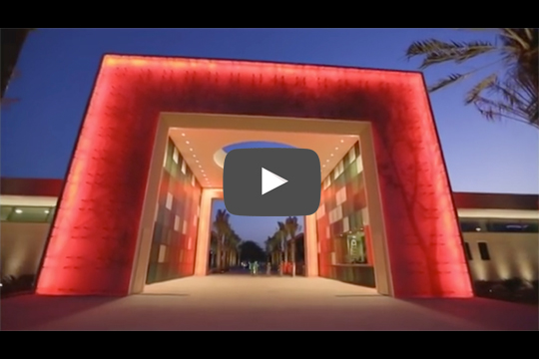
The Park's transformation into a 'people's park' includes a children's museum, petting zoo, botanic garden, fountains and jogging trails. According to the Mother of the Nation Park website, the new park "supports the platform for 'education through recreation' for various age groups, [creates] opportunities for different community sectors to implement their common goals, promotes an active lifestyle that contributes to a healthy society and encourages the dynamic local culture, heritage and tradition."

The country's rich history inspired ArtHouse Design to create culturally responsive designs, including a comprehensive, bilingual wayfinding and signage program for the 30-acre park that represents the local culture, landscape and wildlife, from the dress code and red crescent emblem to the Hajar Mountains and date palm, which Emiratis view as the ultimate symbol of sustainability.

"One of this project's challenges was to provide engaging experiential features for guests after dark due to the intense summer heat in the United Arab Emirates," said ArtHouse Senior Designer Beth Rosa. "Our design solution was to create illuminated custom benches and seats that change colors as visitors walk by or sit."

Additional highlights of ArtHouse Design's work for Mother of the Nation Park:
- A custom visitors map with symbolic iconography and display kiosks
- Sand-blasted pavers outlining the history of the date palm and the fauna of the UAE
- Hand-drawn, bronze-cast fish sculptures in the central promenade fountain
- A monumental entry pavilion with hundreds of color-changing, kinetically illuminated glass panels etched with a custom tree illustration
- 8 interactive animal exhibits for the Animal Barn/Petting Zoo exhibit
- Decorative banners throughout the park and around the exterior perimeter of the park
- Gateway monument entry signs
- A wall-mounted directional sign and additional small directional signs
- Building-mounted typography
- Room/Restroom identification signage
- Garden/Amenity educational panels
- City bus wraps to advertise the park throughout Abu Dhabi

-more-
The Mother of the Nation redevelopment project team includes BrightView Design Group–JamesHyatt Studio, SA Miro, Al Ain Properties, and Sheikha Shamsa Bint Hamdan Al Nahyan, as well as ArtHouse designers who have come and gone: Clara Carpenter, Patrick Kennedy, Chuck Desmoineaux and Brittany Sidwell.

"Over the years, our design team has changed, but we've remained steadfast in our commitment to respect and celebrate the culture and history of the United Arab Emirates," said ArtHouse Principal Designer Marty Gregg. "We wanted to create an innovative environment that gracefully blends Emirati heritage with approachable art that people will enjoy for years to come."

ArtHouse Design won a 2015 GDUSA American Graphic Design Awards Award of Recognition, 2015 HOW International Design Awards Award of Merit, and 2015 American Society of Landscape Architects (Colorado chapter) Merit Award for its design work on this project.

Source: The Written Effect, 720.989.1912

About ArtHouse Design
ArtHouse Design is a Denver-based, full-service design agency devoted to the creation of beautiful, thoughtful design. Nimble and versatile, ArtHouse has a wide range of expertise, from wayfinding and signage to branding and logos, from print and packaging to digital and web. Specializing in designing and shaping user-friendly, built environments, ArtHouse leads the experiential and environmental graphic design industry in art direction for architecture and interior design. Principal Designer Marty Gregg actively leads in the design community, serving as vice president for development at AIGA Colorado and president of the Community College of Denver's design advisory board. Gregg is also a member of the advisory board to Colorado State University’s design department, serves on the Mayor’s Committee on Vital Signs for the City and County of Denver, and engages in speaking events across the country. At ArtHouse, Gregg leads a team of designers who creatively develop, enhance and reinvigorate brands while communicating their clients’ visions and goals. Maintaining the highest standards for both their work and relationships with clients, ArtHouse designers are constantly endeavoring to share their passion for design and to make it an enjoyable and fulfilling process along the way. For more information, visit www.arthousedenver.com.

Media Contacts
ArtHouse Design: Mindy Viering, Writer, Editor and PR Specialist
(call/text) 720.989.1912, mindy@thewritteneffect.com

Click here to download high-resolution photos.
Click here to visit ArtHouse Design's online newsroom.

###

